Walkthrough 14 Custom CSS and Theme Colors

https://sapui5.hana.ondemand.com/#/topic/723f4b2334e344c08269159797f6f796

Core Changed Codes Compared to Last Version:

Manifest.json

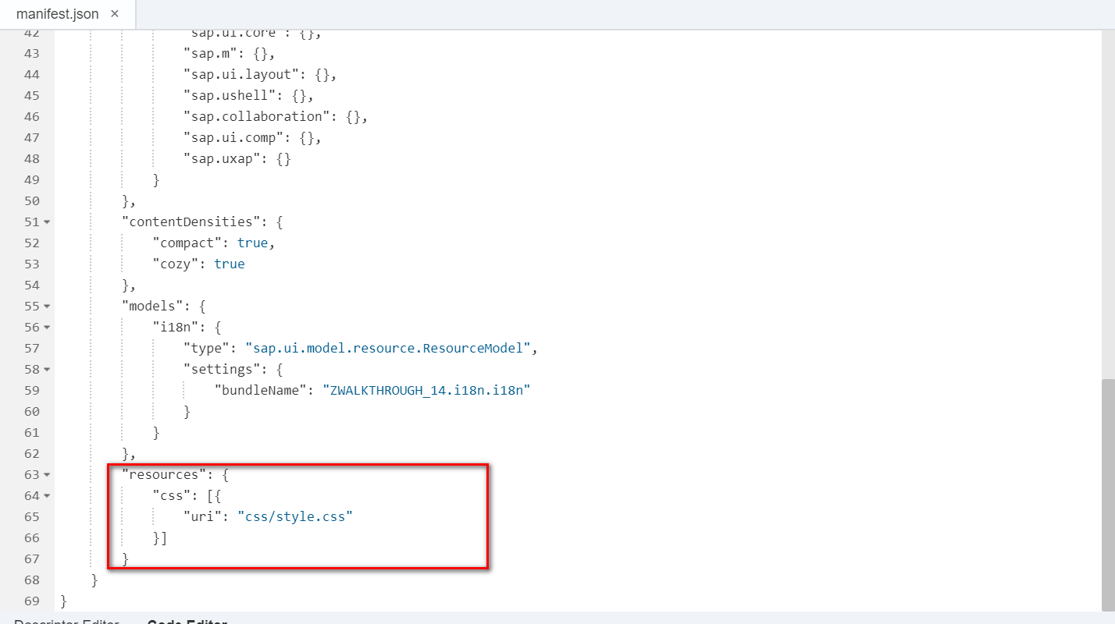

I18n

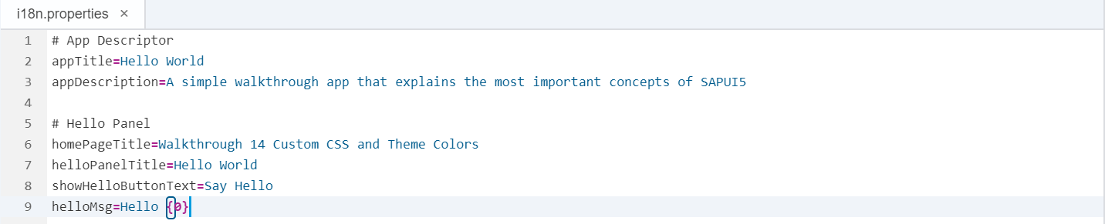

View

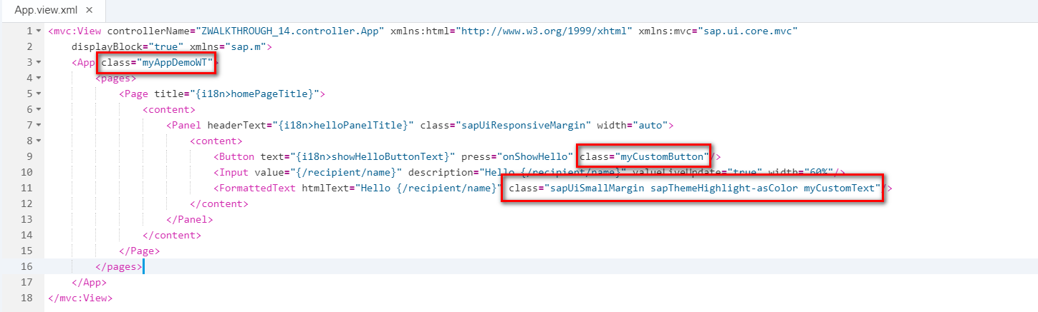

css

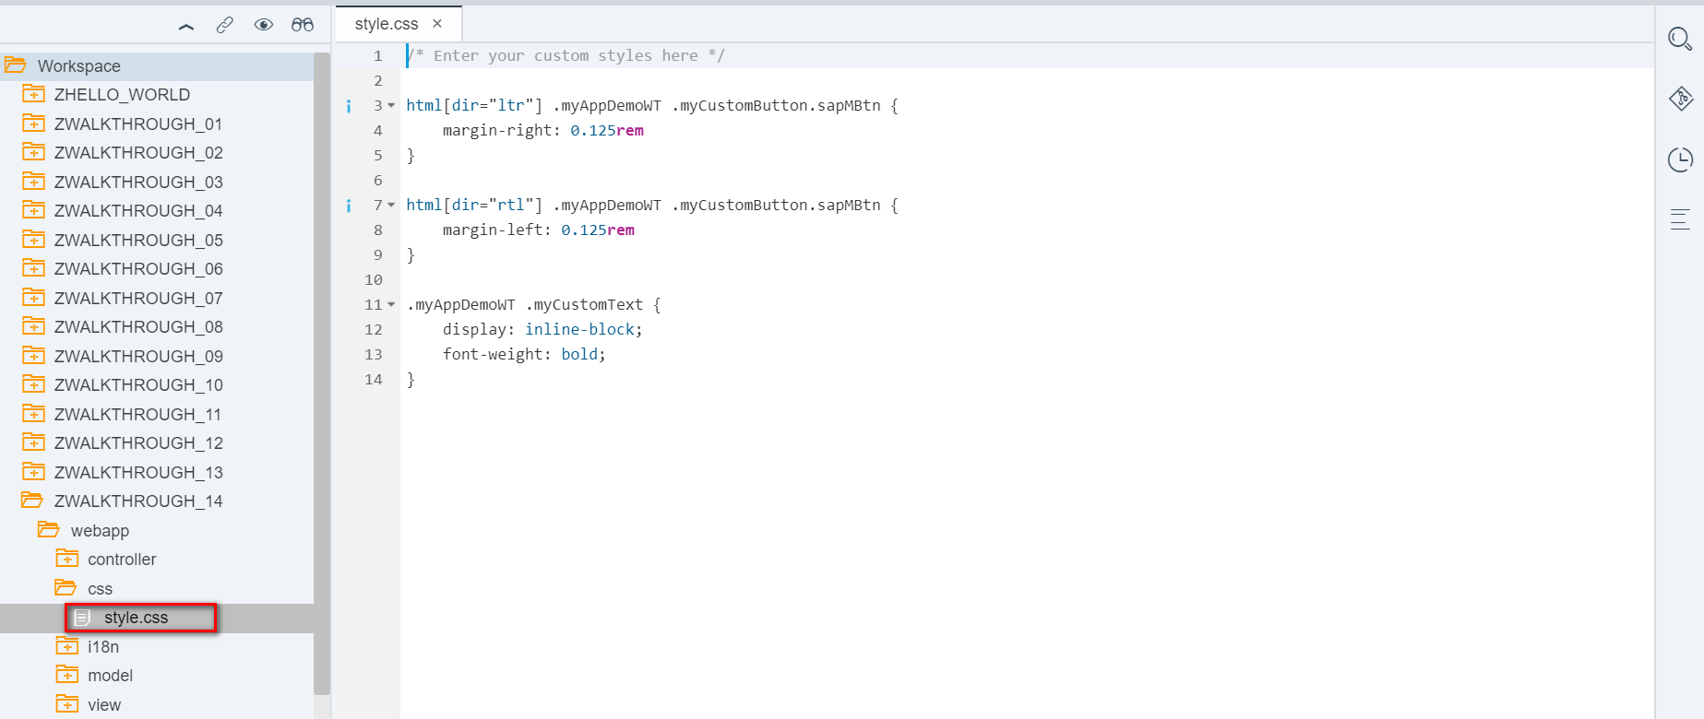

Result:

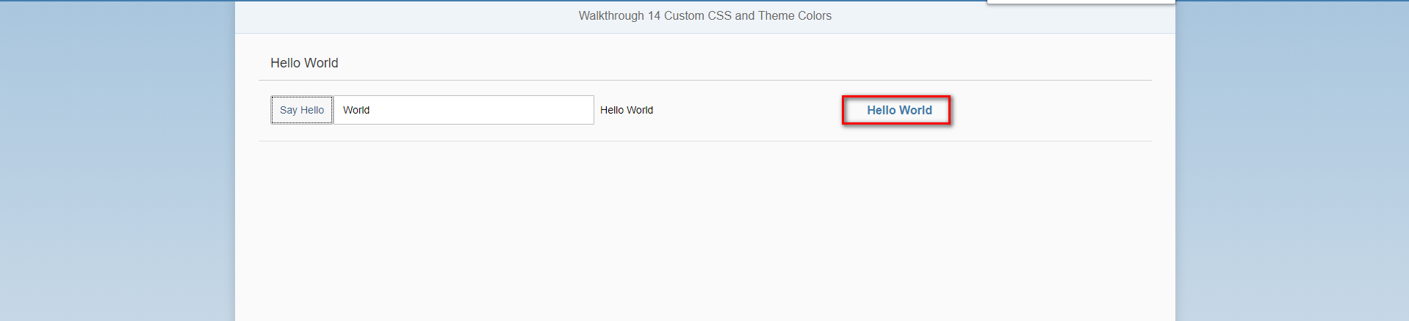

Git:

WALKTHROUGH_14

2018/11/02 XiaoMi Beijing Zac,Xie